Hi Dev,   
  
I have investigated the flow named **Contact In Progress | Send Email,** I have checked all of its run and came to know that flow fails only when it is required to send an email on behalf of[**intakedocs@metromin.org**](mailto:intakedocs@metromin.org)shared email.   
  
When contact record application status is not “In-progress”, then flow didn’t give error because not required to send email.

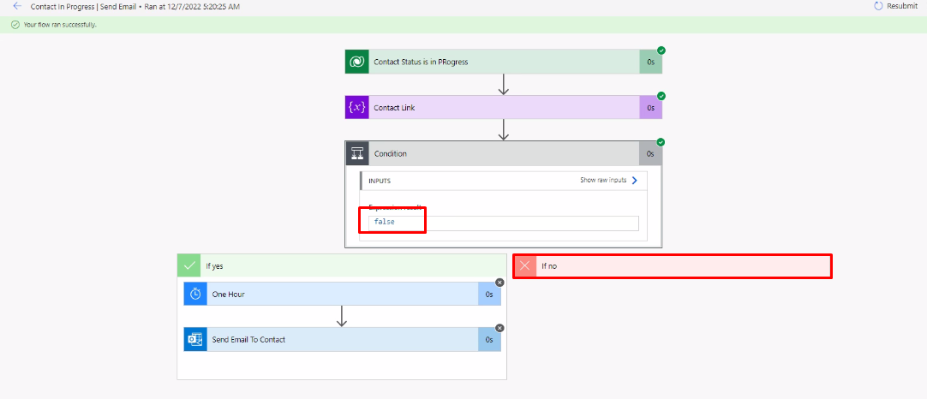

But when record application status is “In-Progress” then flow is going into true part and required to send email on behalf of [**intakedocs@metromin.org**](mailto:intakedocs@metromin.org)this shared email address and throwing error.

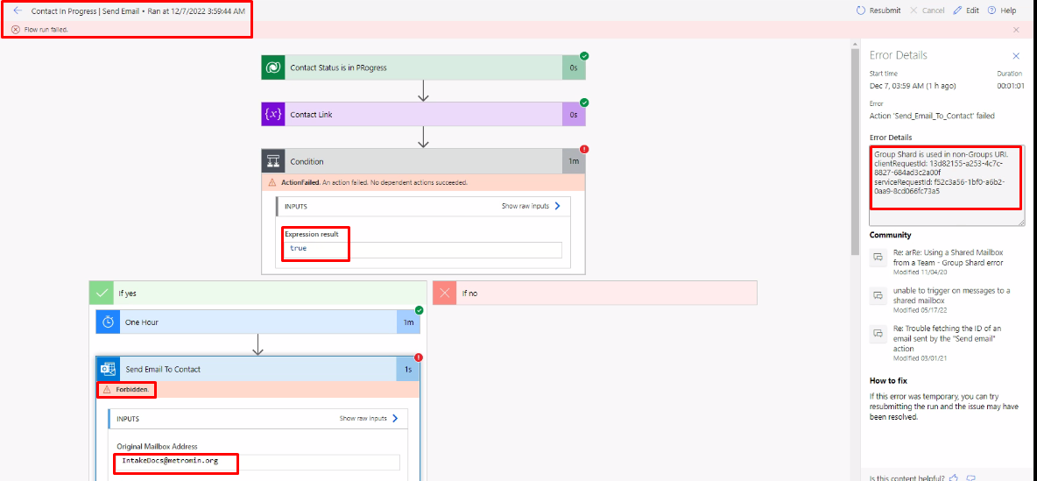

Here in this image, you can see that when condition expression result is true then email is being send on behalf of **intakedocs@metromin.org** mailbox address and the result of this action is “Forbidden”.

When we see mailbox address in dev CRM, and search [intakedocs@metromin.org](mailto:intakedocs@metromin.org) this mail address over there, that mailbox not exists over there. Need to add this mailbox in dev environment to use in flow with **complete permissions.**

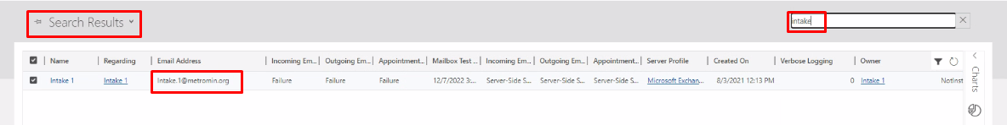

While [intakedocs@metromin.org](mailto:intakedocs@metromin.org) mailbox exists into prod with all permissions therefor flow is working in prod as expected.

In Prod environment:

